THEMENBLOCK 10: Language & Communication

CATEGORY A: CONTRASTING IMAGES
═════════════════════════════════════════════════════════
TASK SET A1: The Quality of Connection

Part 1 — Individual Long Turn

Task:
Give a five-minute talk on the quality of communication in which you
- describe, compare and contrast the two pictures above.
- analyze how the number of people we communicate with affects the depth of our conversations.
- comment on how you balance staying connected with many people while maintaining meaningful relationships.

Part 2 — Paired Activity
Your school is launching a "Quality Communication Week" to encourage students to have more meaningful conversations. You and your partner have been asked to design the campaign. Discuss the following campaign elements and agree on three to focus on:
- "Phone-free lunch zones" in the cafeteria
- Workshops on active listening skills
- A "One Deep Conversation" daily challenge
- Posters highlighting the benefits of face-to-face communication
- Student testimonials about meaningful conversations that changed their perspective
═════════════════════════════════════════════════════════
TASK SET A2: Traditional vs. Digital Communication

Part 1 — Individual Long Turn



Task:
Give a five-minute talk on forms of communication in which you
- describe, compare and contrast the pictures above.
- evaluate the pros and cons of both quick digital messages and slower, handwritten communication.
- comment on which method you prefer for staying in touch.

Part 2 — Paired Activity
Your English class is conducting a research project on how communication methods affect relationships. You and your partner need to decide which research questions to prioritize. Discuss the following questions and agree on three to focus your research on:
- Does the effort we put into a message affect how valued the recipient feels?
- Are handwritten letters making a comeback among young people, and why?
- How has instant messaging changed our expectations for response times?
- Do emojis and GIFs help or hinder genuine emotional expression?
- What communication methods do people choose for important life moments (birthdays, condolences, thank-yous)?
═════════════════════════════════════════════════════════

TASK SET A3: Beyond Words

Part 1 — Individual Long Turn
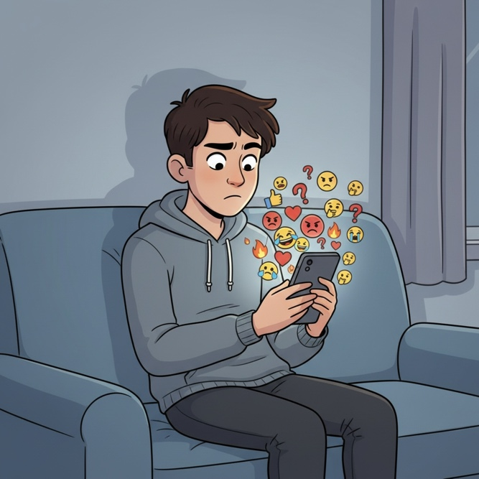

Task:
Give a five-minute talk on communication and understanding in which you
- describe, compare and contrast the two pictures above.
- discuss whether face-to-face communication leads to better understanding than digital communication
- recall a personal experience of text-based miscommunication and how it might have been avoided

Part 2 — Paired Activity
Your school is organizing a "World of Communication" day to help students understand different forms of expression. You and your partner are on the planning committee. Discuss the following activities and agree on three to include in the program:
- Sign language basics workshop taught by a deaf educator
- "Emoji Pictionary" game — guessing phrases using only emojis
- Body language awareness session — reading non-verbal cues
- Cross-cultural gestures presentation — same gesture, different meanings
- Silent communication challenge — conveying messages without words for 30 minutes

CATEGORY B: QUOTES
═════════════════════════════════════════════════════════
TASK SET B1: Language and the Limits of Thought

Part 1 — Individual Long Turn
Quote 1:
"The limits of my language mean the limits of my world."
— Ludwig Wittgenstein, Tractatus Logico-Philosophicus (1922)
Quote 2:
"To have another language is to possess a second soul."
— Charlemagne, attributed (no verified primary source)
Task:
Give a five-minute talk on language and thought in which you
- analyze and compare the two quotes above and discuss what each author means.
- evaluate whether learning a new language really changes how we think or see the world.
- comment on how knowing multiple languages has affected your perspective.

Part 2 — Paired Activity
You are student representatives meeting with a language education specialist to advise your school on introducing a multilingual awareness program. You need to decide which aspects to prioritize. Discuss the following focus areas and agree on three to recommend:
- Heritage language support for students whose families speak other languages at home
- "Language of the month" cultural awareness activities
- Exchange partnerships with schools in other countries
- Offering a third foreign language as an elective
- Training teachers to use multilingual approaches in all subjects

TASK SET B2: Texting: Linguistic Ruin or Renaissance?

Part 1 — Individual Long Turn
Quote 1:
"There is increasing evidence that texting helps rather than hinders literacy."
— David Crystal, Txtng: The Gr8 Db8 (2008)
Quote 2:
"Texters are vandals who are doing to our language what Genghis Khan did to his neighbours 800 years ago. They are destroying it."
— John Humphrys, Daily Mail (2007)
Task:
Give a five-minute talk on texting and language in which you
- critically analyze the two quotes above and explain why the authors hold such different views.
- discuss whether texting, social media, and digital communication are changing language for better or worse.
- comment on your own texting habits and whether you think they affect your writing skills.

Part 2 — Paired Activity
Your school is holding a debate on the motion: "Digital communication is damaging young people's language skills." Take turns arguing for and against the motion, then try to reach a balanced conclusion. Consider these aspects:
- Spelling and grammar standards in formal writing
- Creativity and linguistic innovation in digital spaces
- Attention span and ability to write longer texts
- Vocabulary development — expanding or shrinking?
- Code-switching: knowing when formal vs. informal language is appropriate

CATEGORY C: ALTERNATIVE PROMPTS
TASK SET C1: Multilingual Europe

Part 1 — Individual Long Turn
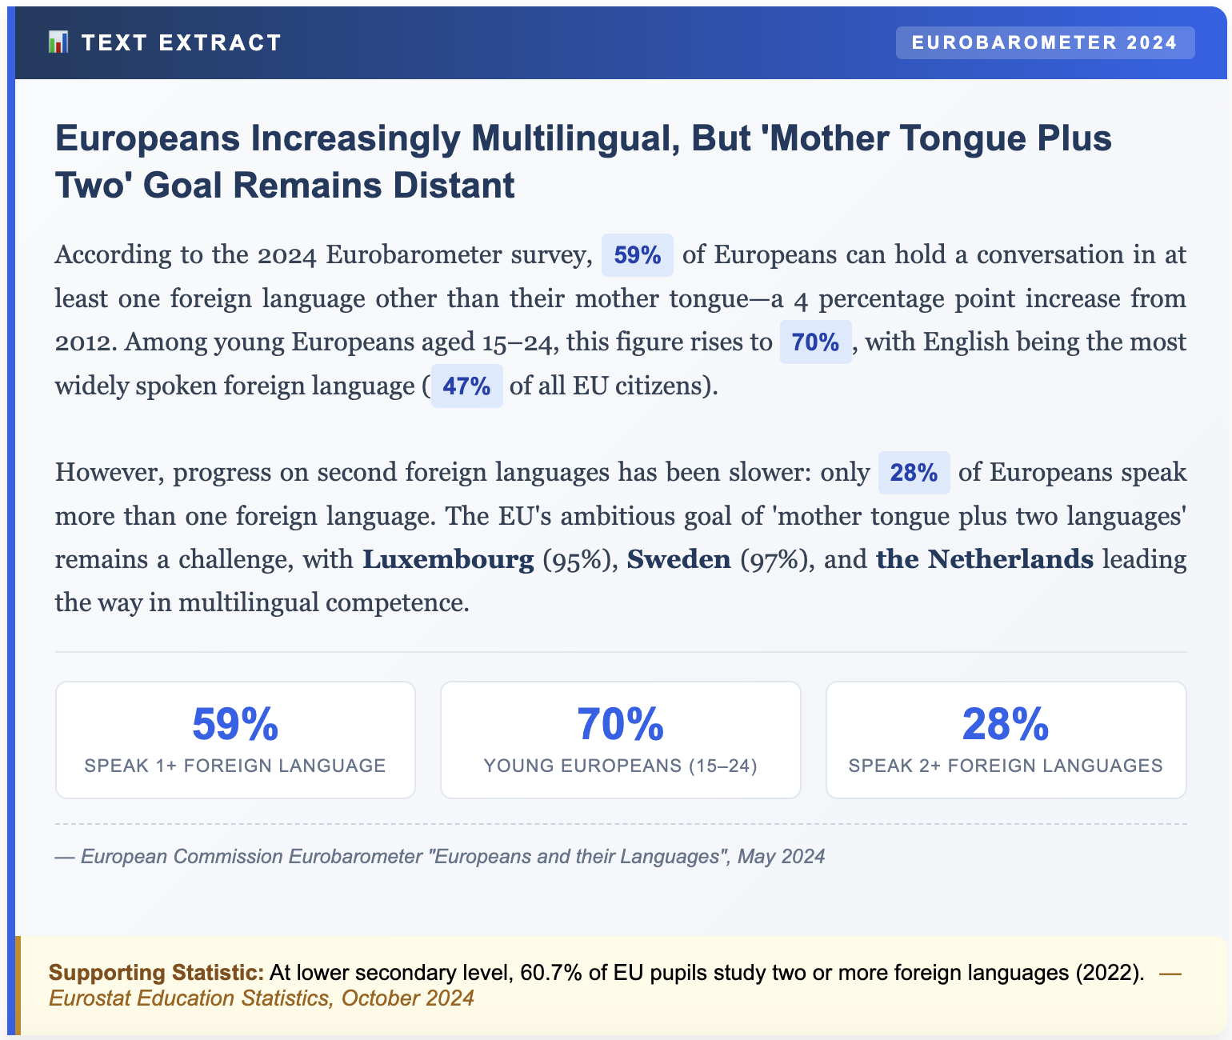
Task: Give a five-minute talk on multilingualism in Europe in which you
- explain the key findings and what they reveal about language learning in Europe.
- analyze why younger Europeans are more multilingual than older generations.
- discuss whether Austria is meeting the EU's 'mother tongue plus two' goal.

Part 2 — Paired Activity
Your school has been invited to send two student representatives to meet with an official from the Austrian Education Ministry. The topic is "How to improve language learning in Austrian schools." Before your meeting, discuss these points and agree on three priorities to raise with the official:
- Starting foreign language learning earlier (in primary school)
- More exchange programs and study abroad opportunities
- Using technology and apps to supplement classroom learning
- Offering more language choices beyond English and French/Spanish
- Training teachers to use more immersive, communicative methods
TASK SET C2: The TikTok Language Classroom

Part 1 — Individual Long Turn
Text Extract:
LEARNING LANGUAGES FROM YOUR PHONE
A study by Trinity College London found that "80% of Gen Z students acquire a significant proportion of their language skills from watching social media platforms like TikTok and Instagram." This shift from traditional classroom learning to informal digital exposure is transforming how young people learn languages.
Through content creators, viral videos, and international communities, teenagers pick up vocabulary, pronunciation, and even slang that textbooks never teach. Duolingo reports that its app has over 500 million registered users worldwide, with many using it alongside — not instead of — traditional classes. The question is no longer whether technology has a place in language learning, but how to harness it effectively.
Sources: Trinity College London study, 2024; European Youth Portal
Task:
Give a five-minute talk on language learning and social media in which you
- explain what the text reveals about how young people learn languages today.
- evaluate the pros and cons of learning language through social media compared to traditional teaching.
- comment on your experience learning languages through social media platforms.

Part 2 — Paired Activity
Your school wants to create resources that help students use social media productively for language learning. You and your partner are suggesting content ideas. Discuss the following ideas and agree on three to develop:
- A curated list of educational TikTok/Instagram accounts for learning English
- Tips for using Netflix/YouTube subtitles to improve language skills
- A guide to language exchange apps and how to use them safely
- Warnings about unreliable language content and common mistakes online
- Student testimonials: "How I improved my English through gaming/streaming"

